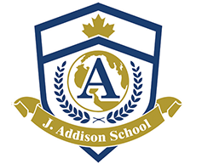 Summer Camp Teacher

At J. Addison, we believe education is an ongoing year-round activity, which brings fulfillment in one’s development. We keep the joy of learning and exploration very much alive during the Summer months (July and August), and we offer 2026 Summer Fusion Day Camp program that are tailored for different age groups and academic needs.
We are currently seeking Summer Camp Teachers (Pursuing OCT/ECE preferred with Primary/Junior qualifications) for our Academic Enrichment summer camp program for children 5-13 yrs. The positions range from 30-40 hrs/week from July 6 - August 14, 2026.

Job Type: Seasonal
Contract length: 6 weeks
Pay: $17.60 - $20 per hour
Benefits:
- Casual dress
- Discounted or free food
- On-site parking
Schedule:
- 6 - 8 hours, day shift
- Monday to Friday
- Expected start date: July 6, 2026
Education:
- Completed High school Diploma or pursuing/completed a Bachelor’s Degree
Experience:
- Teaching: 1 year (preferred)
Please share your application to jobs@jaddisonschool.com. We will reach out to you if your skills and experience look good to us.

We will not utilize artificial intelligence for screening, assessing or selecting applicants. However, our team member will reach out only to shortlisted candidates for interviews. We appreciate all applications. J. Addison School is an equal opportunity employer; please let us know if you require any accommodation.

